Tool Teaching Order:
1. Magnet  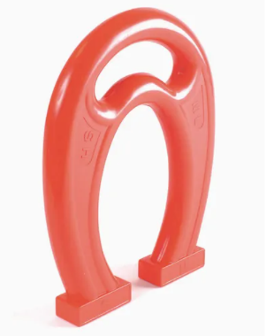 | 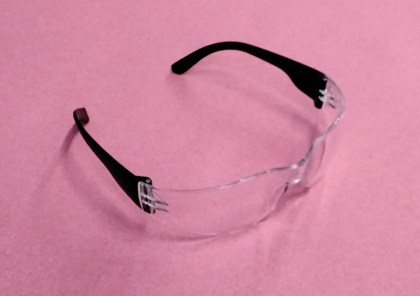  2. Safety Glasses | 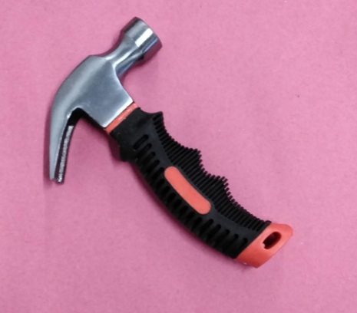  3. Claw Hammer | 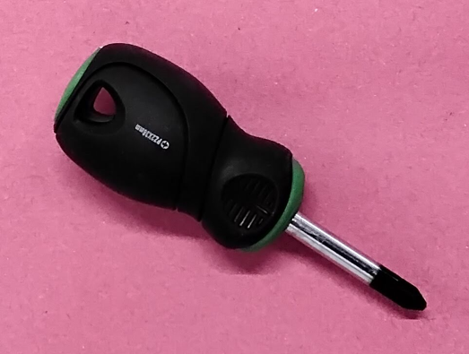  4. Screwdriver
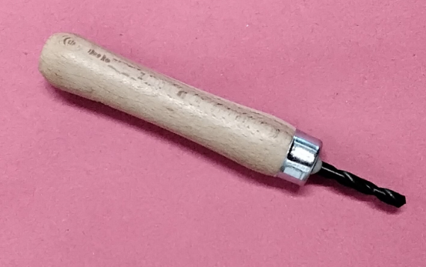  5. Palm Drill | 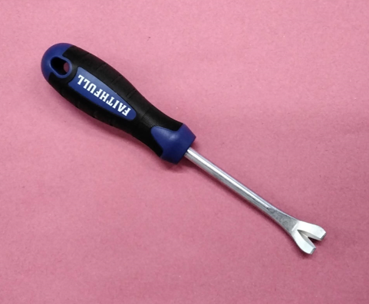  6. Tack Lift | 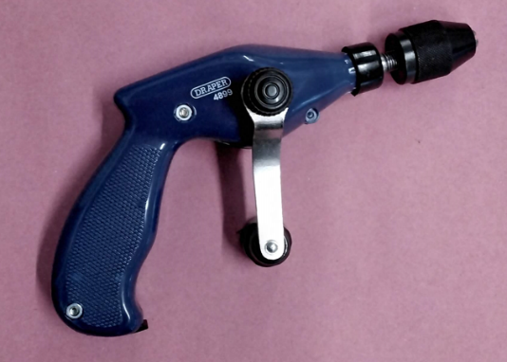  7. Pistol Drill | 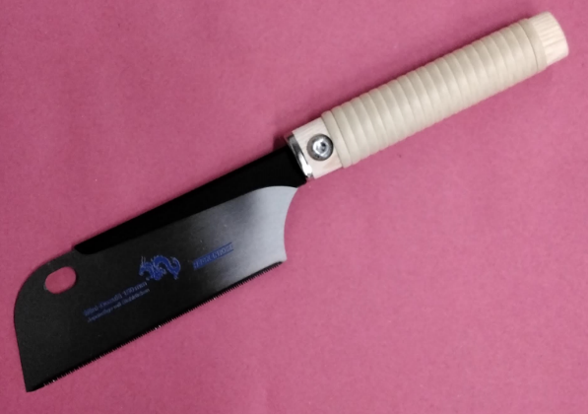  8. Saw

Wood Progression:
Start with Balsa Wood | Progress to Soft Pine
- Very soft wood  - Generally used for model making  - Offers little resistance to nails and screws  - Easy to cut  - Ends unlikely to need sanding. | - Fairly soft wood  - Offers some resistance to nails and screws so good to progress onto when children find Balsa wood too soft.  - Fairly easy to cut  - Ends may need sanding after cutting
Wood sizes
- Start with long pieces of wood that children can easily hold away from the ‘work’ end. | - Progress onto smaller pieces so children have to manipulate the wood and the active working area with more control.

Project Progression:
Start with focus on skills of using tools  - No plan in mind  - Just using nails or screws into wood. | Begin to think about placing pieces with purpose  - Selecting corks/bottle tops  - Wanting to connect specific items | Have a clear end goal in mind and actively work towards it  - Say what they want to make before they start  - Knowing what materials they will need to achieve end goal  - Placing pieces with purpose  - Is able to talk about what they are making

