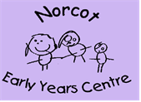
Song and Rhyme Spine

2-3 year olds:  - Open, shut them  - Two little dickie birds  - Wheels on the bus  - Round and round the garden, like a teddy bear  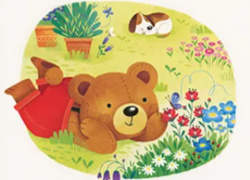 | All rooms  with progression onto alternative versions and additional verses for 3-4 year olds:  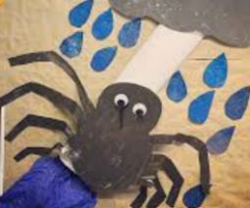  - Twinkle twinkle little star (chocolate bar)  - Incy wincy spider (freeze)  - Baa baa black sheep (other colours/patterns)  - Wind the bobbin up (small and large)  - Roly Poly (opposites version)  - Old McDonald (variations ie zoo, park)  - Head shoulders knees and toes (to include face)  - Sleeping bunnies (alternative actions or animals)    - Row, row, row your boat (to include lake, sea, river) | 3 -4 year olds:  - 1, 2, 3, 4, 5 once I caught a fish alive  - 5 little ducks  - 5 speckled frogs  - If you’re happy and you know it  - I had a little turtle  - 5 current buns  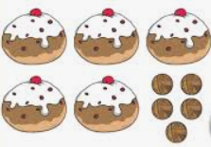
Butterfly Room:

- Wheels on the bus
- 5 little ducks
- Baa baa black sheep
- Twinkle twinkle little star
- Incy wincy spider
- Row, row, row your boat
- Old McDonald

